**Question1 :**You are provided with a ReactJS application and it can be found on the repository with the link provided below.

Create a Dockerfile for this React application and also create image and run the image as container and the output of the ReactJS application should be shown on the localhost.

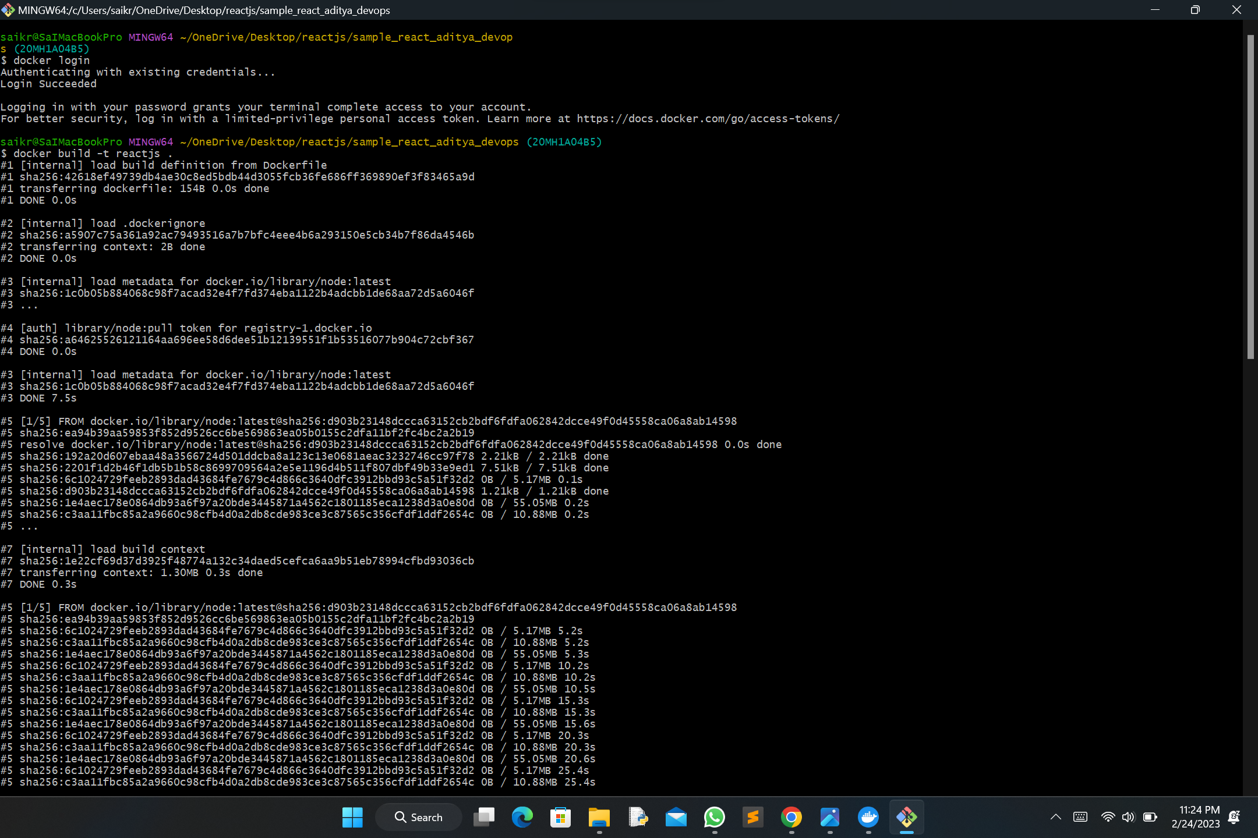

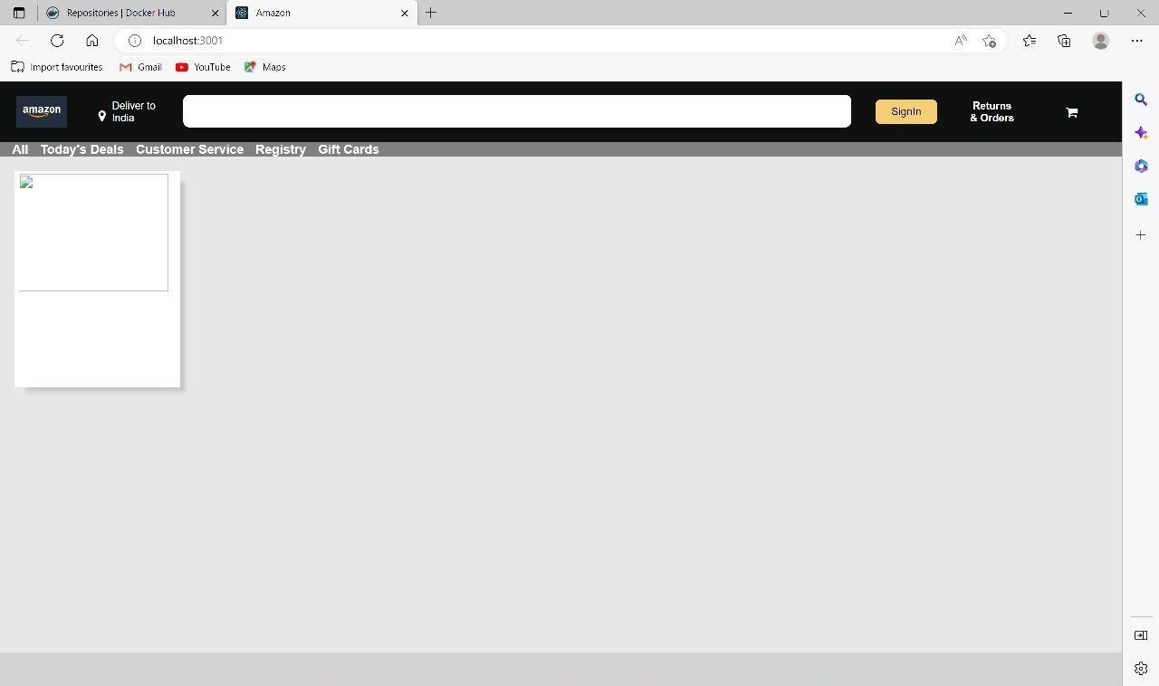

2. Describe the CI-CD pipeline and also describe the role of jenkins here.

Ans: CI-CD pipeline is used for the automate the process of building, testing, and deploying software applications. It consists of a series of stages,each of which involves a set of automated tasks that ensure that software is developed and deployed consistently and efficiently.

ci-cd:continuos integration and continus delivery.

Code 🡪merge🡪build🡪 test automatically deploy to production

Jenkins : it is a open source automation tool that plays a major role in implementing the ci-cd pipeline .it is a continuous integration and continuous delivery .the ci-cd tool that provides an easy to use for automating software development processes

